

Mr.Bo Jangles Salon

MSBA 504 Final Project-Case Study

October 13, 2022

# 

# 

# Table of Contents

1. Table of Contents pg.1
2. Executive Summary pg. 2
3. Team Member introductions, roles and contributions pg. 3
4. Client Introduction pg. 4
5. Current situation and requirements definition pg. 4
6. Initial and modified ERDs of proposed database system pg.6
7. Logical relational schema pg. 7
8. Tables and Queries pg.8
9. Technical issues, quirks of the system, major challenges pg. 16
10. Lessons learned pg.17
11. Scenario B pg.18
12. Appendices pg. 21

# 

# Executive Summary

Izzie and Jamie, Co- founders of Mr. Bo Jangles grooming salon, need help reaching their two goals. The first one being, organizing and keeping their records/data up to date. Their second goal of offering more services to their clients. Our team was hired to ensure that the business and technical needs of the grooming salon are taken care of so that the operations of the grooming salon can execute more efficiently. Our strategy to help eliminate inefficiency and stress was to create a database system for the grooming salon to implement. To do this we designed a model that consisted of an ERD, dictionary entries, database schema, tables and queries. The ultimate goal for our team was for this new database system to provide various tools that would be useful to the company. Some of those tools consist of table listings for all assets of the company, reports on quarter revenues, customer satisfaction scores, and other bookkeeping records. The report then goes into detail about some of the challenges we faced along the way and lessons we learned. We conclude our project with tools from our database system that can help Izzie, Jamie and plausible pet chains make the decision to sell and/or buy Mr.Bo Jangles grooming salon.

# 

# Team Member introductions and contributions

1. Ugo Oduozo

University of San Diego ‘23

Master of Business Analytics

Contribution; Database design, relationship build, data entry and cleaning, context & clarity, query data

1. Fatima Maya Castellanos

University of San Diego ‘23

Master of Business Analytics

Contributions: Database design, data entry, data cleaning, constructed report and powerpoint

1. Kevin Howard

University of San Diego ‘23

Master of Business Analytics

Contributions: Master Data Management

1. Andrew Hochstetler

University of San Diego ‘23

Master of Business Administration

Master of Business Analytics

Contributions: Database Architecture, Relationship Construction, Data Cleaning, Data Entry, Quality Control, Roadblock Removal, Scope Coordination, Context Provider

# 

# Client Introduction

Mr.Bo Jangles grooming salon was founded in May 2020 by Izzie and Jamie. In a short amount of time, these two young women developed a well established business with a great reputation and wide business connections. Mr. Bo Jangles grooming salon offers a basic service package, which includes: bath, blow dry and brush. In addition, they have specialty services that can be added to the basic service package such as: haircut, nail trim, ear cleaning, teeth brushing,etc. The cost of these services depends on the weight of the animal and the length of the coat. The salon takes both appointments and walk-ins. Furthermore, they have a staff of ten general employees, two of which are office employees, eight of them are groomers and the last two are part-time employees. Their entire information system is paper based and because of this, paper files are misplaced and lost. Although their salon has been exponentially growing successfully over the past few years, they have been under major stress within their operations due to business and technical issues. In addition, Izzie and Jamie are wanting to sell their business services and products to an interested pet chain. Their accountant advised them to transition to a database system for efficiency and cost saving.

# 

# Current situation and requirements definition

Izzy and Jamie’s business have recorded so much growth and success over the years but they are currently facing a challenge of properly keeping their records due to the high volume of data available and this is affecting overall business operations.

They have hired our team of Database administrator experts to help solve this problem with their major goal being to ultimately have record keeping updated and organized, and to offer more services to their clients.

Our team of DBA experts have come up with a roadmap plan on steps to take towards providing a solution, these includes creating a data dictionary to define all data required with appropriate field context, next an entity relationship diagram needs to be created including all data types and relationships between entities (tables), normalization of tables is essential for a robust database, this is where the DBAs checks for data redundancy, ensure proper data validation and relationships are set. A database is then created within SQL to capture all tables with appropriate data populated, the database is further queried to ensure it’s aligned with the business expectation. The business owners and their employees are trained on how the database system works and our team wraps up the project by providing recommendations to the business for growth and expansion.

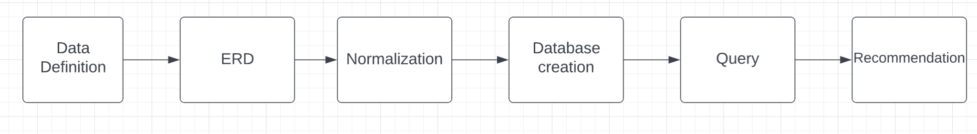

# 

# Initial and modified ERDs of proposed database system

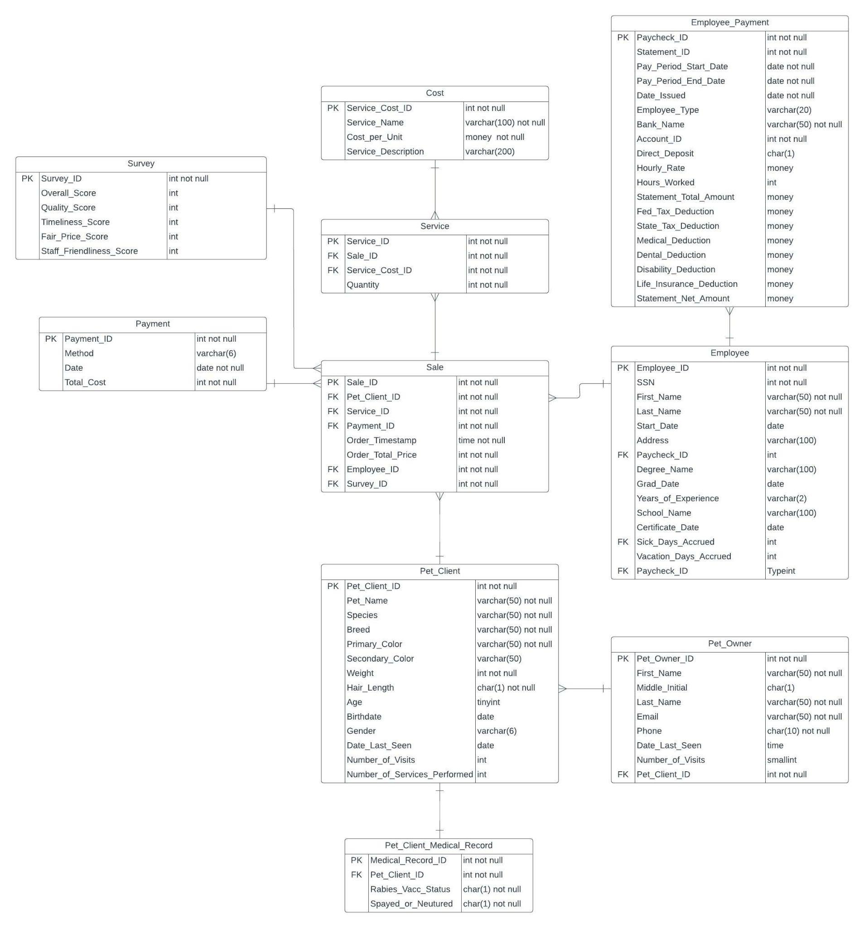

# 

# Logical relational schema

We started by drafting 14 tables we identified as core requirements in our data dictionary along with considering scenario B. Then we drafted the ERD by simply creating the boxes without creating relations between the tables. When we started working on the logical relational schema, we started noticing that certain fields within tables and certain tables altogether weren't necessary. We spent a good investment of time in a conference room really adding and deleting fields and making sure they were assigned the appropriate data type. Where things really got messy is when we tried assigning primary keys and foreign keys, because we realize here that normalization comes into play to make sense out of the table relations. We eventually got our draft ERD completed and went to work on drafting the tables. Creating the tables and the relation constraints took some time, as we learned that you must build non-dependent tables first and the dependent tables but still need to have a process for logically entering constraints. Once we got to the data input once the tables were built, this is where most of the database work lay. We used Azure SQL studio and were able to input all the data after a lot of time investment in formatting the input data correctly. In the end, we were able to successfully relate our tables and perform the joins that were laid out in the case study and assignment instructions.

# 

# Screen Capture of Tables and Queries

1. Select *

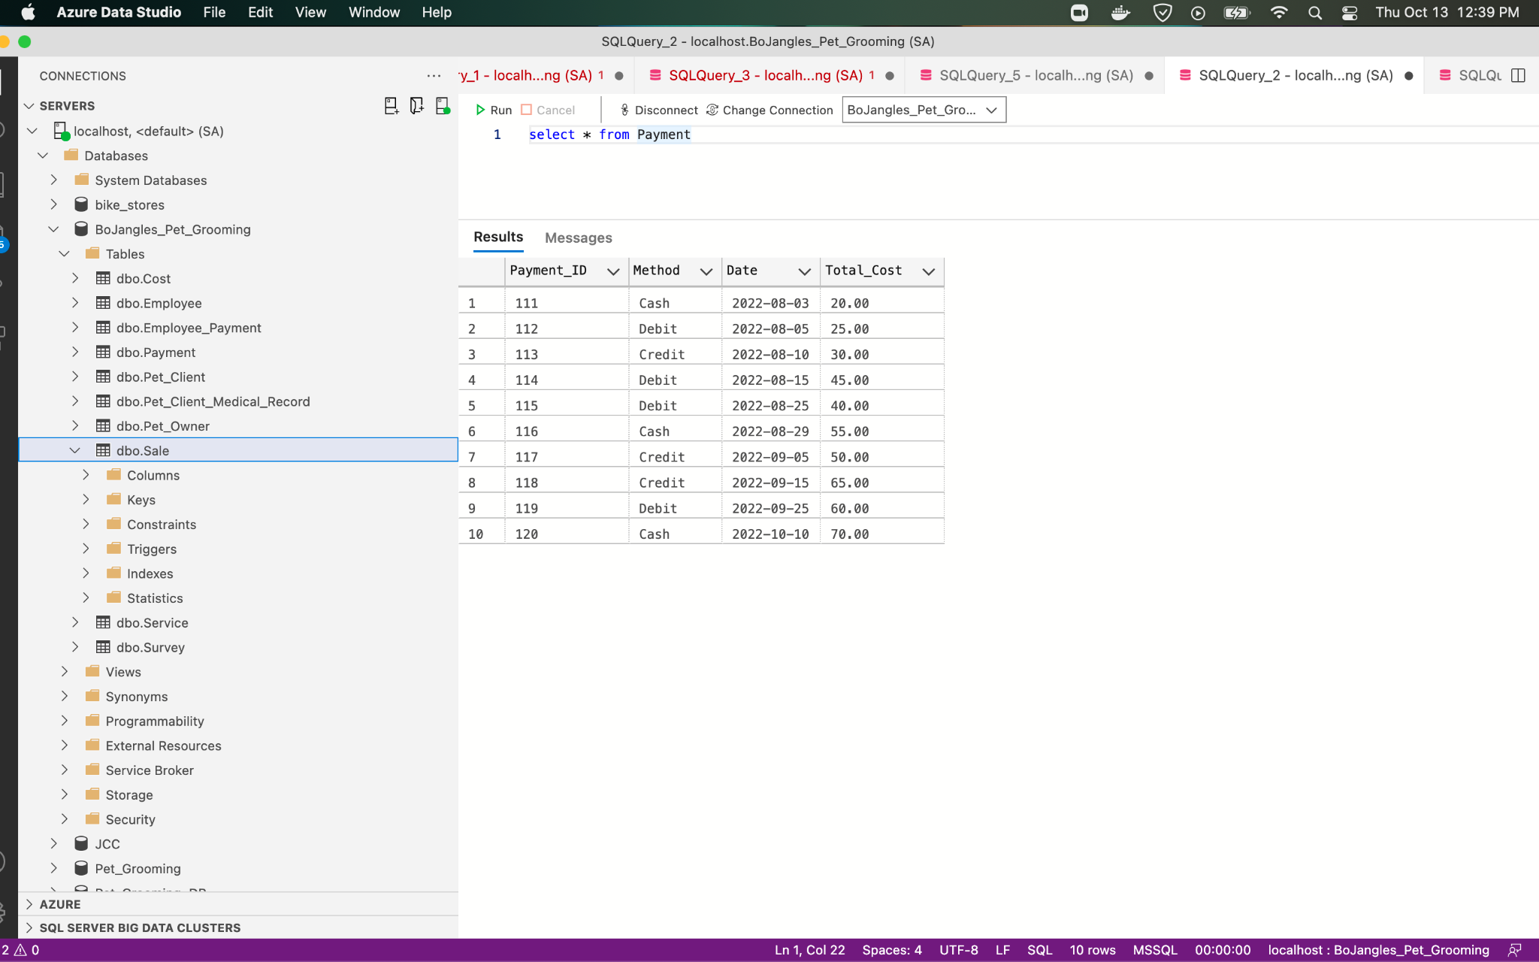

2)

/*Q1 22 REVENUE */

SELECT SUM (TOTAL_COST)

FROM PAYMENT

WHERE DATE BETWEEN 01/01/2022 AND 3/31/2022

3)

/*Q4 21 REVENUE */

SELECT SUM (TOTAL_COST)

FROM PAYMENT

WHERE DATE BETWEEN 10/01/2021 AND 12/31/2021

4)

Screenshot of standalone table (Select *) with all assets and costs (and totals)

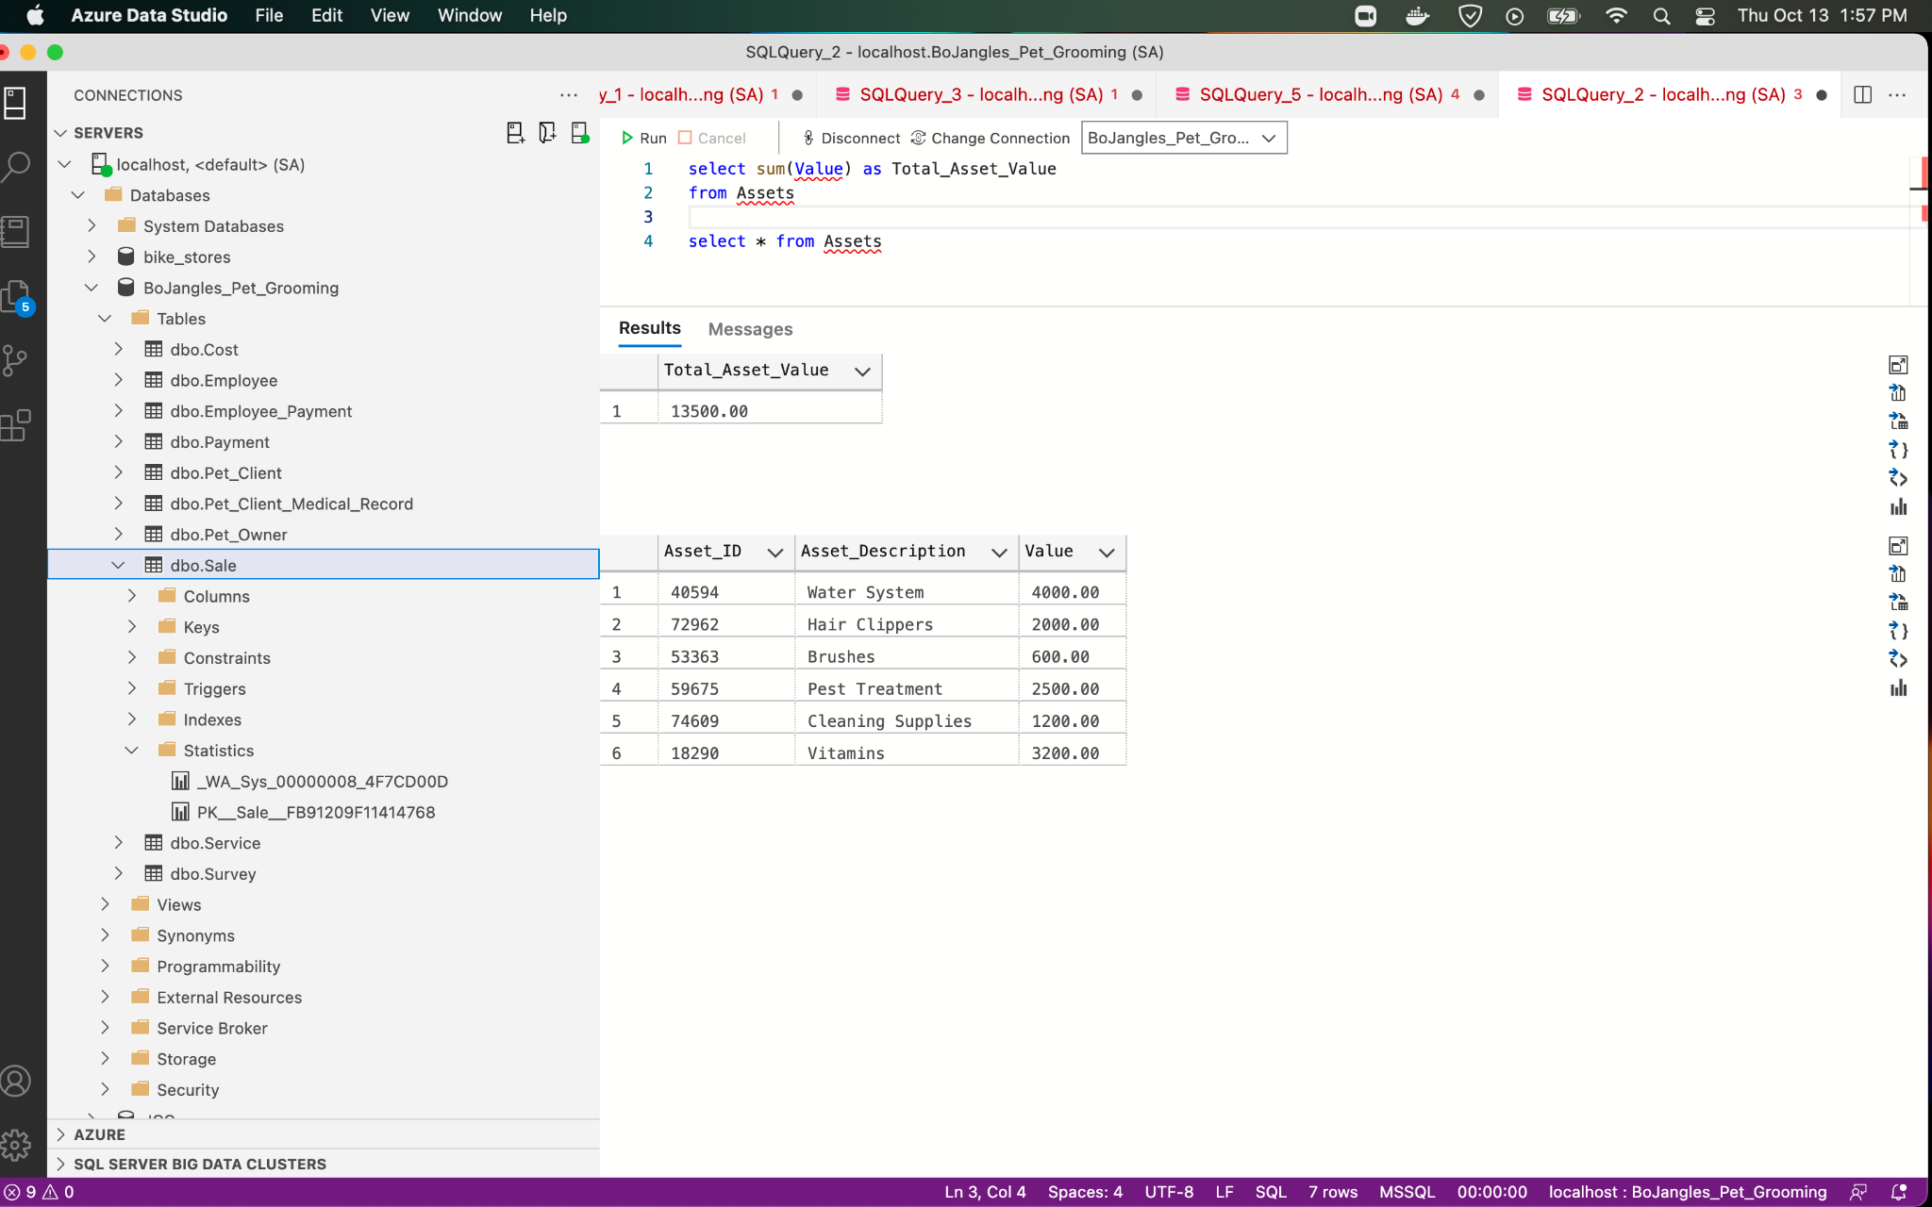

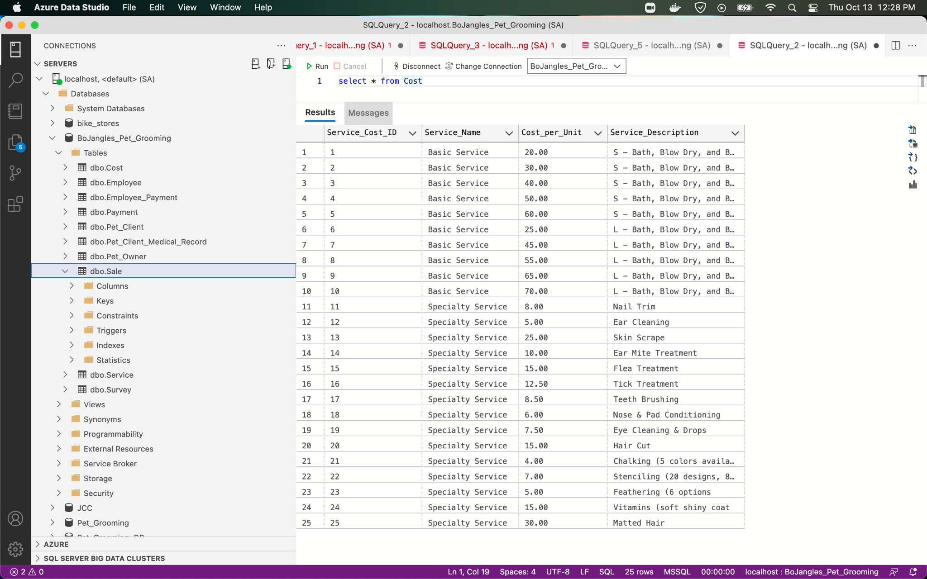

5)

Screenshot of table (Select *) with all Customer Satisfaction scores (and totals)

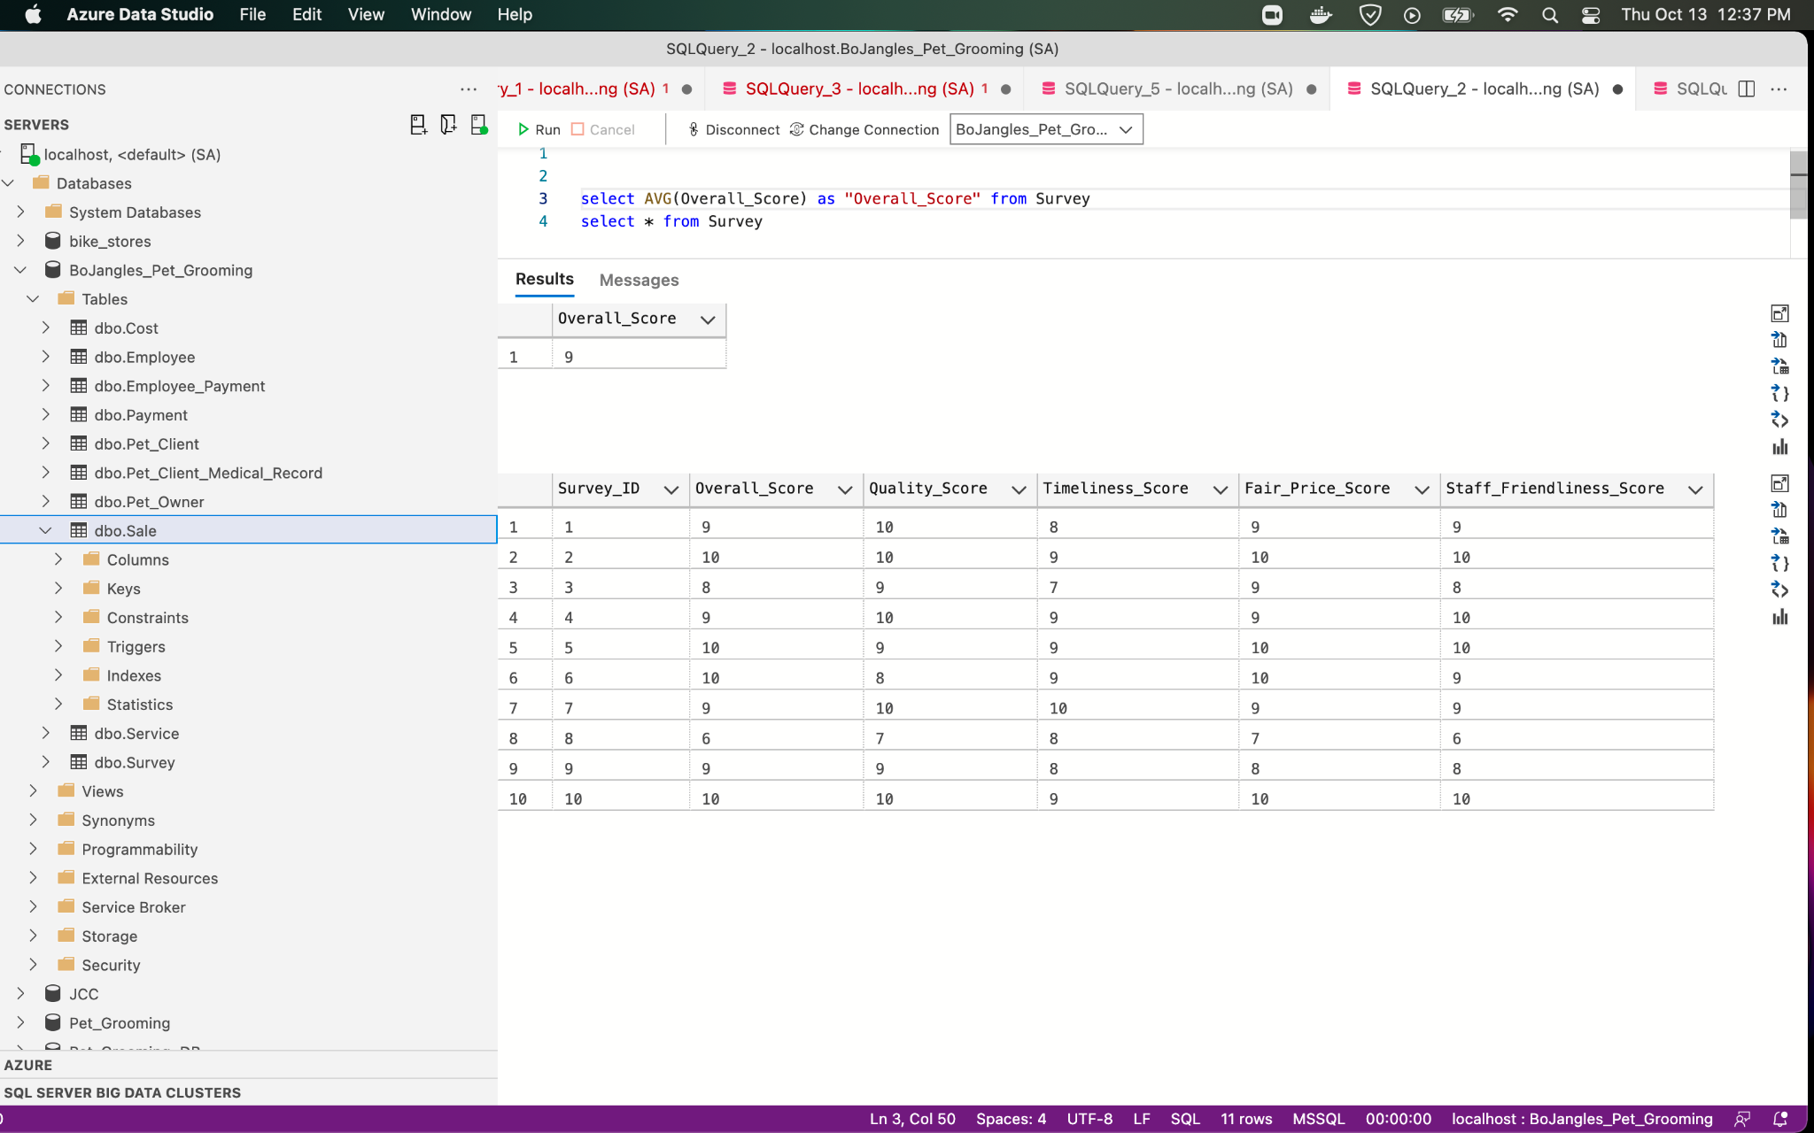

6)

Names of groomers and their clients, and number of times each client was groomed.

SELECT Pet_Owner.First_Name, Pet_Owner.Last_Name, Pet_Client.Pet_Name, Pet_Client.Number_of_Services_Performed

FROM Pet_Owner

Inner join Pet_Client

On Pet_Owner.Pet_Owner_ID = Pet_Client.Pet_Owner_ID

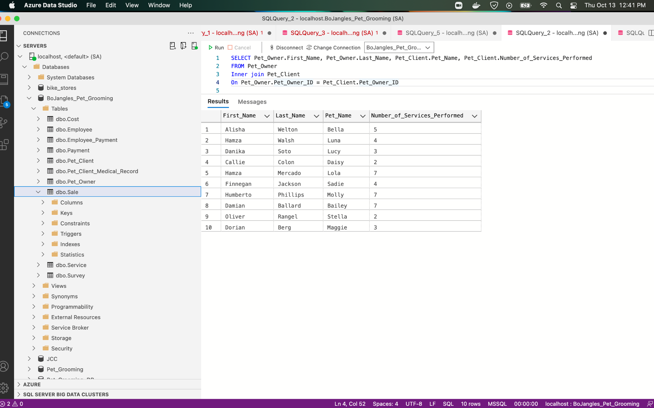

7)

Names of clients not seen in the last year and date last seen.

SELECT Pet_Name, Date_Last_Seen

FROM Pet_Client

WHERE Date_Last_Seen < 01-01-2022

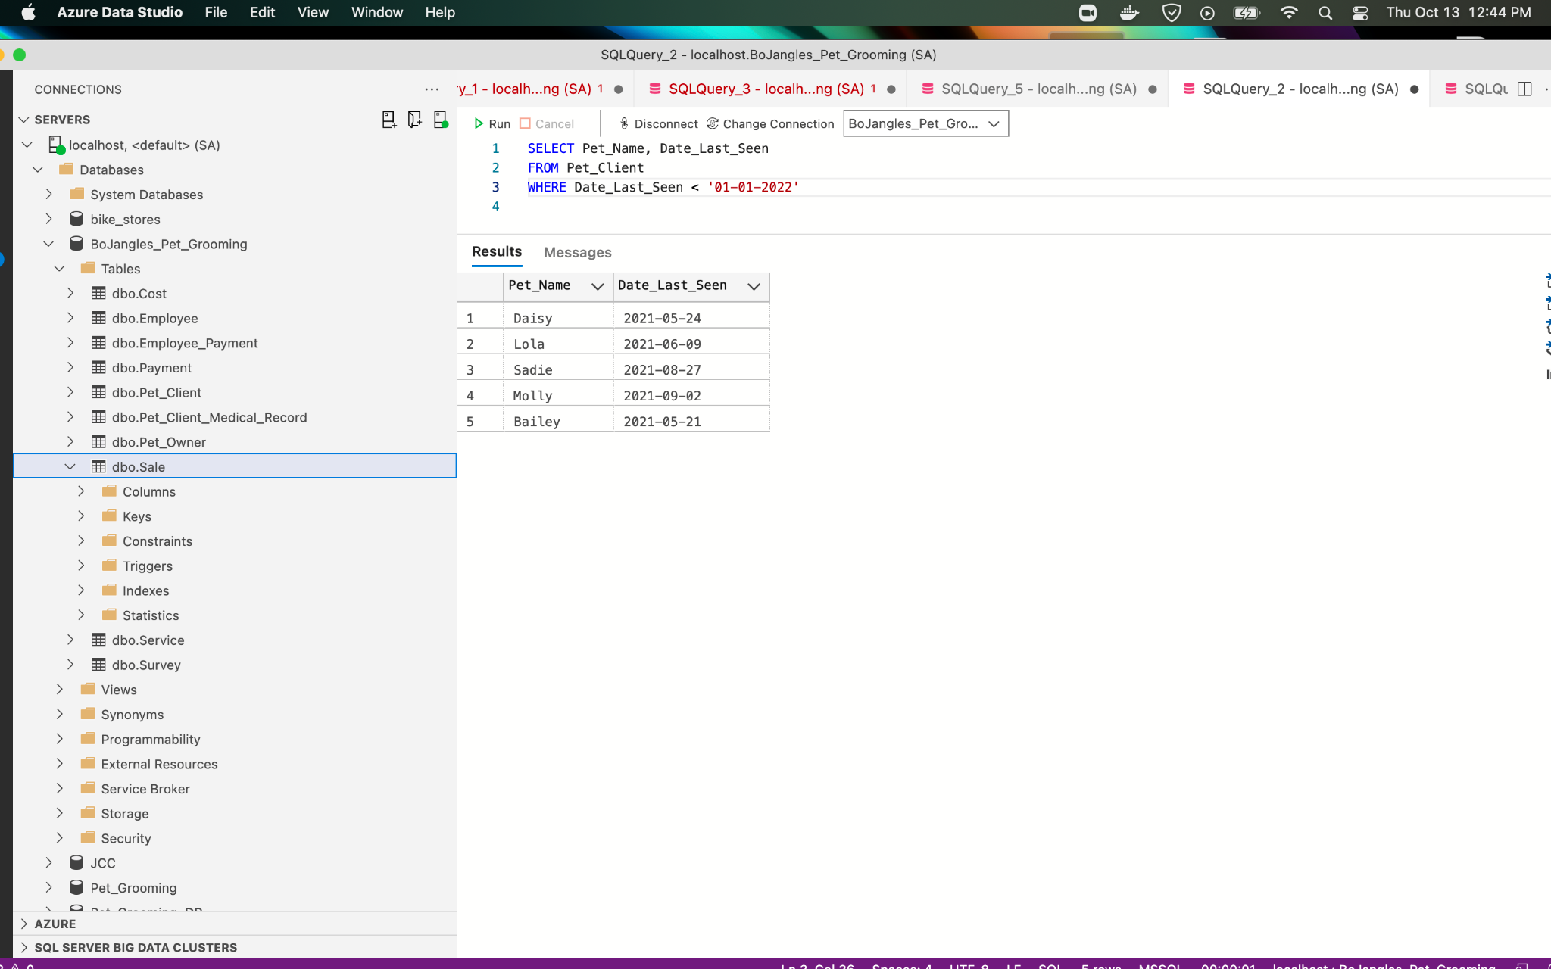

8)

Services performed on animals most often (by species).

SELECT Species , Service_name , Quantity

FROM Pet_Client pc, Cost c, Service s, Sale sl

WHERE sl.Pet_Client_ID = pc.Pet_Client_ID

AND sl.Service_ID = s.Service_ID

ORDER BY Quantity DESC

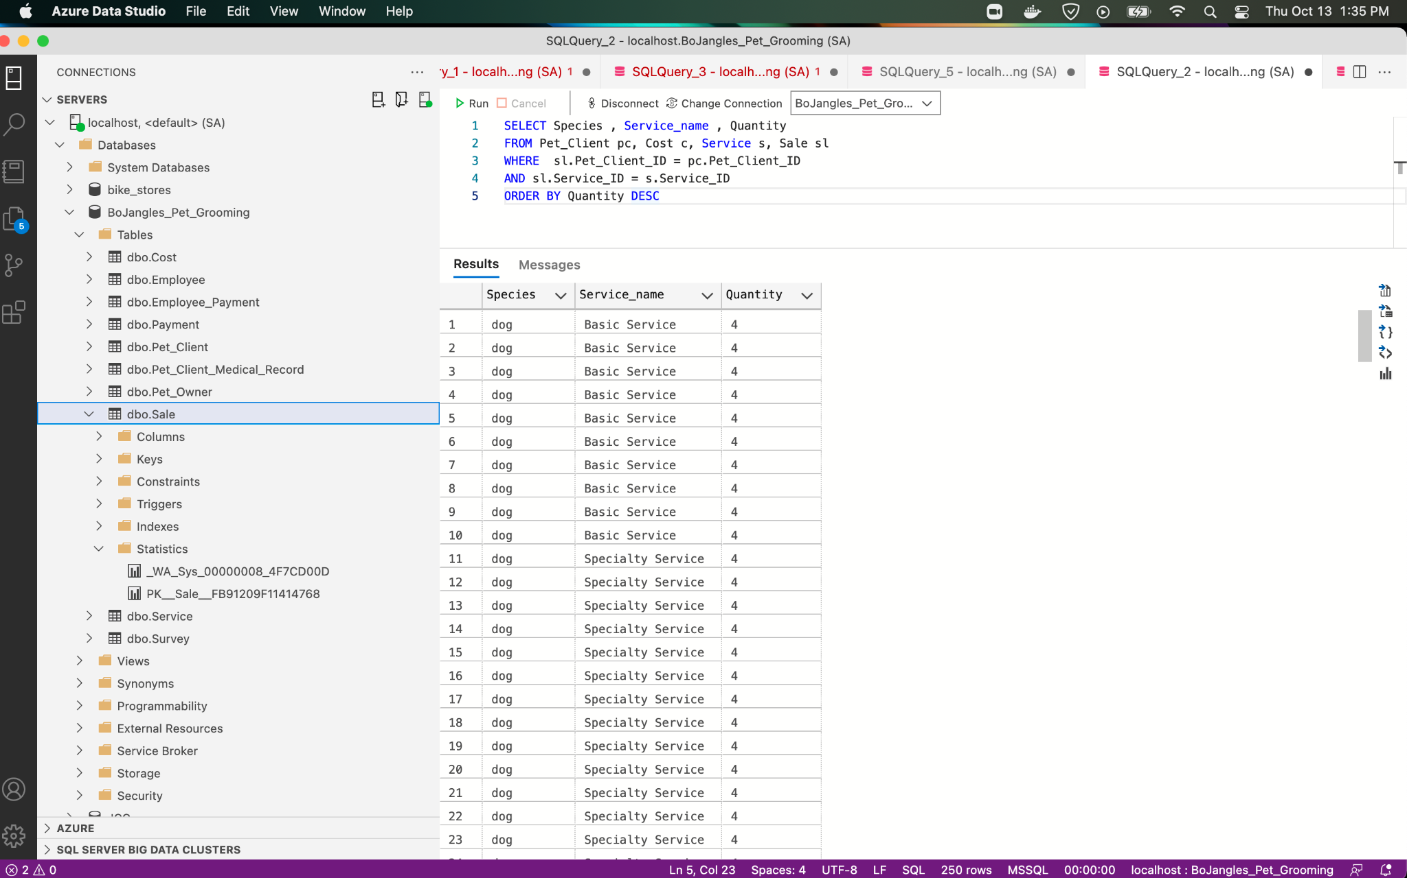

**Which client has had the same walk-in service performed more than once?

- Do we have any fields that captures weather a service was walk-in or appointment

9)

A listing of owners, clients in decreasing order by number of grooming visits.

SELECT Pet_Owner.First_Name, Pet_Owner.Last_Name, Pet_Client.Pet_Name, Pet_Client.Number_of_Vists

FROM Pet_Owner

Inner Join Pet_Client

On Pet_Owner_ID = Pet_Client_ID

ORDER BY Pet_Client.Number_of_Visits DESC;

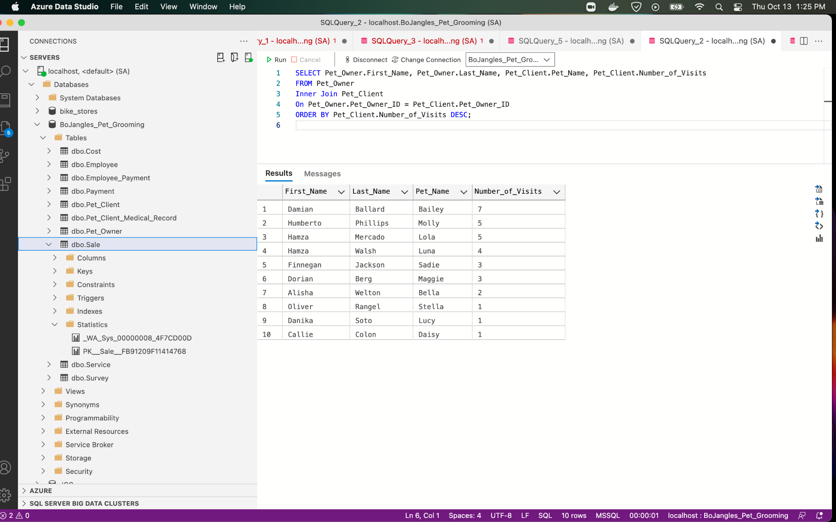

10)

Client that has been groomed the most often

SELECT Pet_Name, Number_of_Services_Performed

FROM Pet_Client

ORDER BY Number_of_Services_Performed DESC

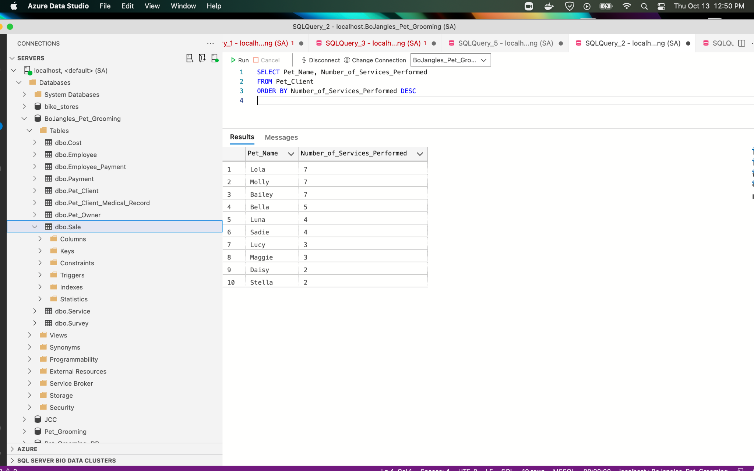

11)

Which employees earn more than the average salary for all employees?

SELECT First_Name, Last_Name, AVG(Statement_Total_Amount) AS Average_Salary

FROM Employee, Employee_Payment

WHERE Employee_ID = Paycheck_ID

AND Statement_Total_Amount >= Average_Salary

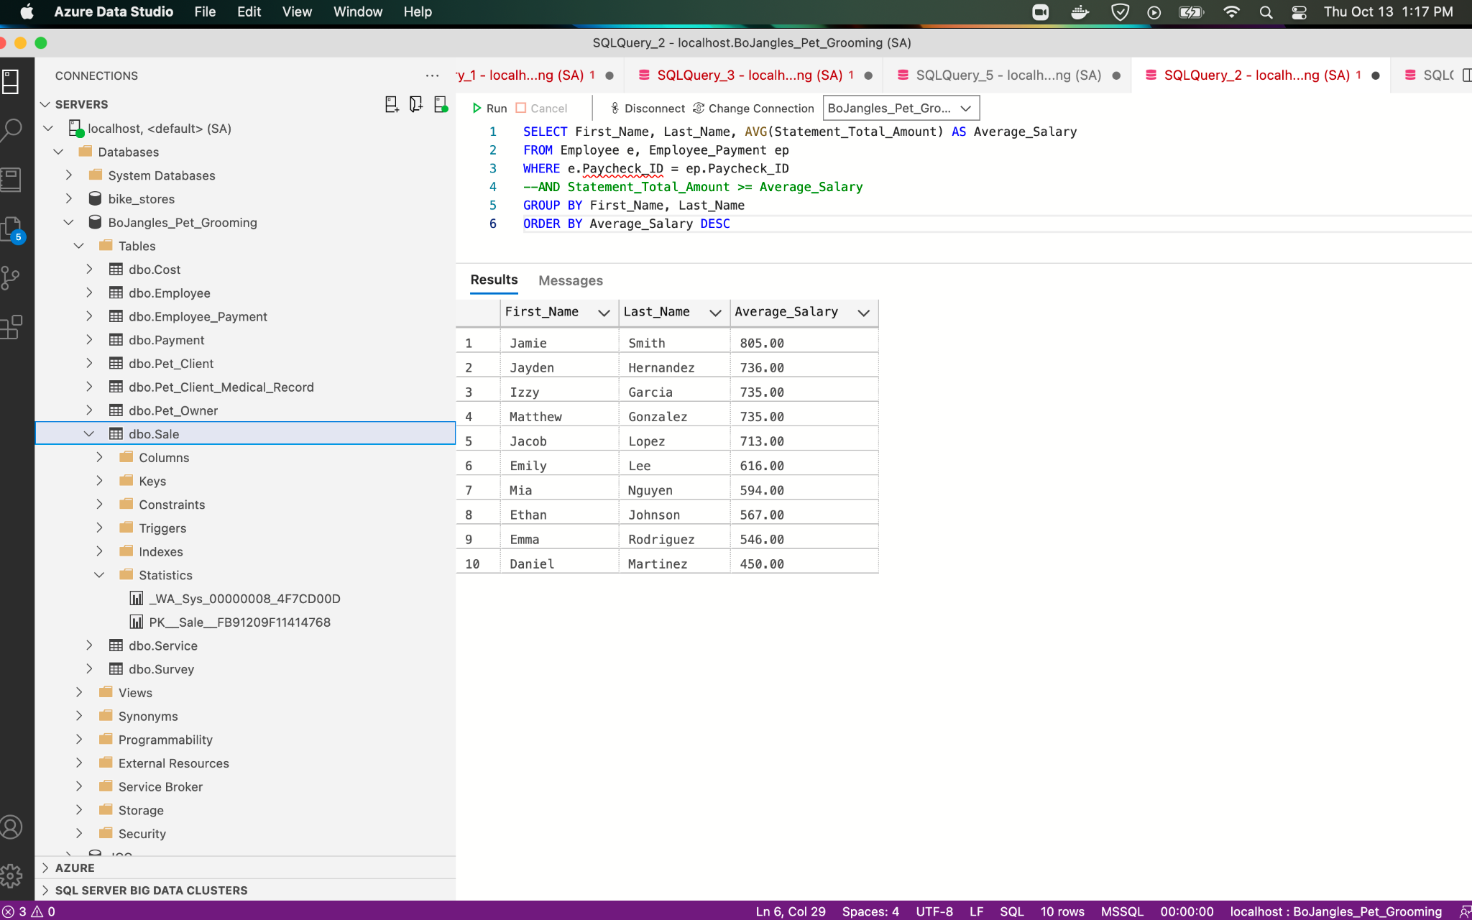

12)

Which part-time employee has been with Mr. Bo Jangles the longest?

SELECT First_Name, Last_Name, Employee_Type, MIN(Start_Date) AS Longest_Stay

FROM Employee as e, Employee_Payment as ep

WHERE e.Paycheck_ID = ep.Paycheck_ID

Group by First_Name, Last_Name, Employee_Type

Order by Longest_Stay

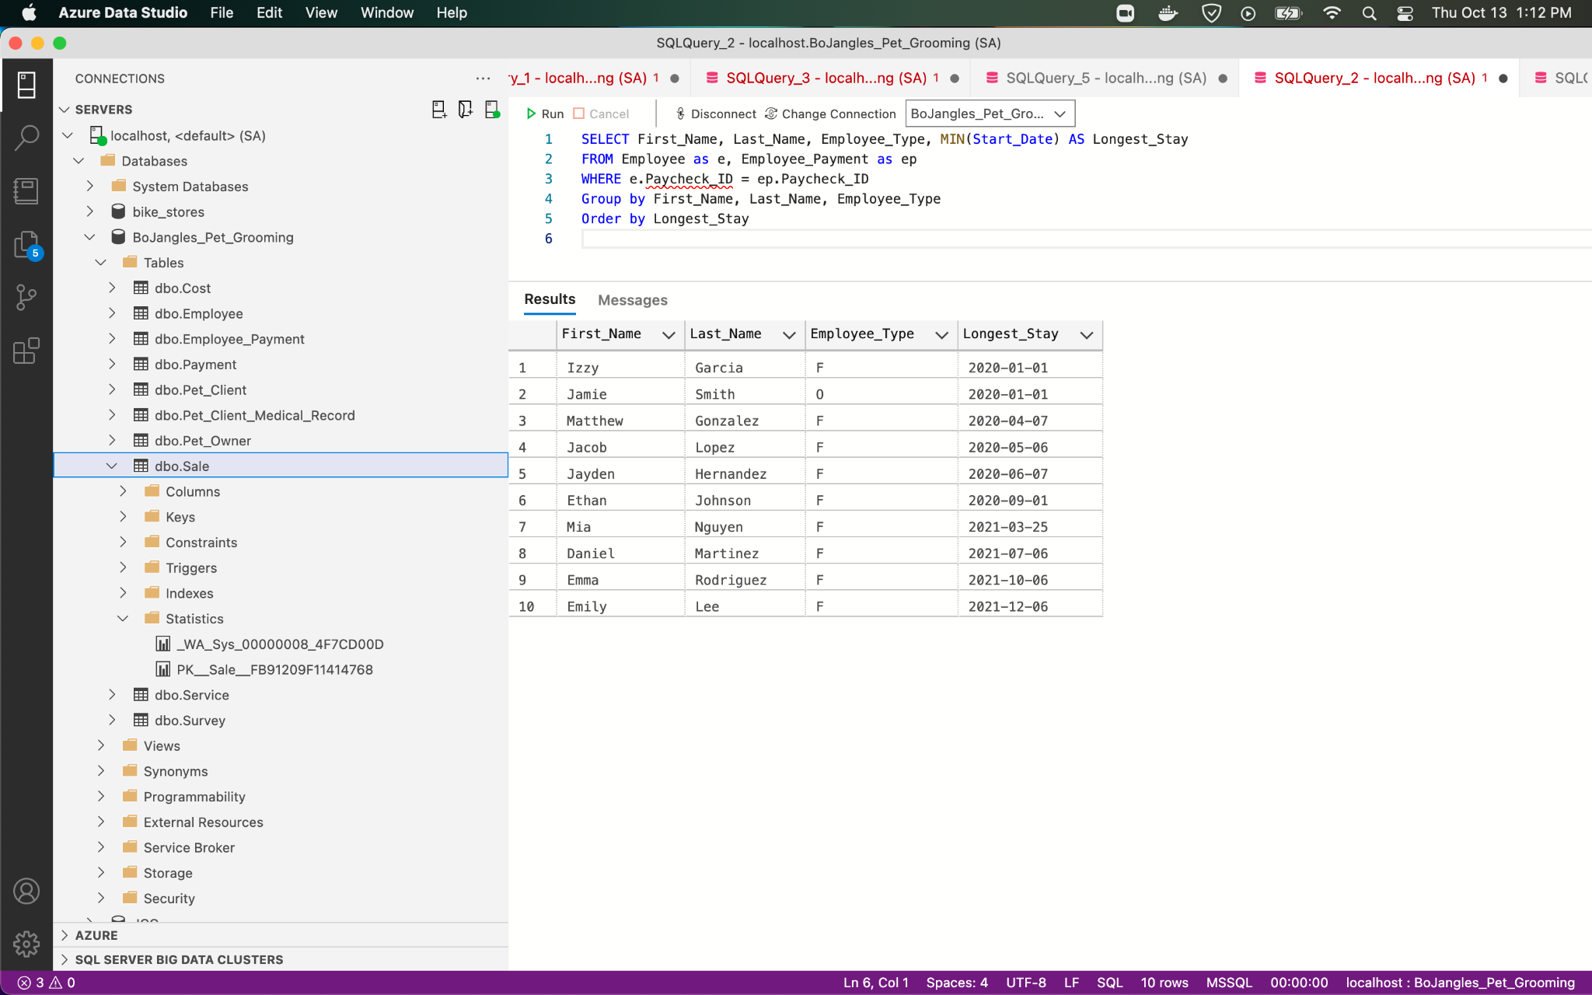

13)

Which employee has the most sick days?

SELECT First_Name, Last_Name, Max(Sick_Days_Accrued) AS Most_Sick_Days_Accrued

FROM Employee

Group By First_Name, Last_Name

Order By Most_Sick_Days_Accrued DESC

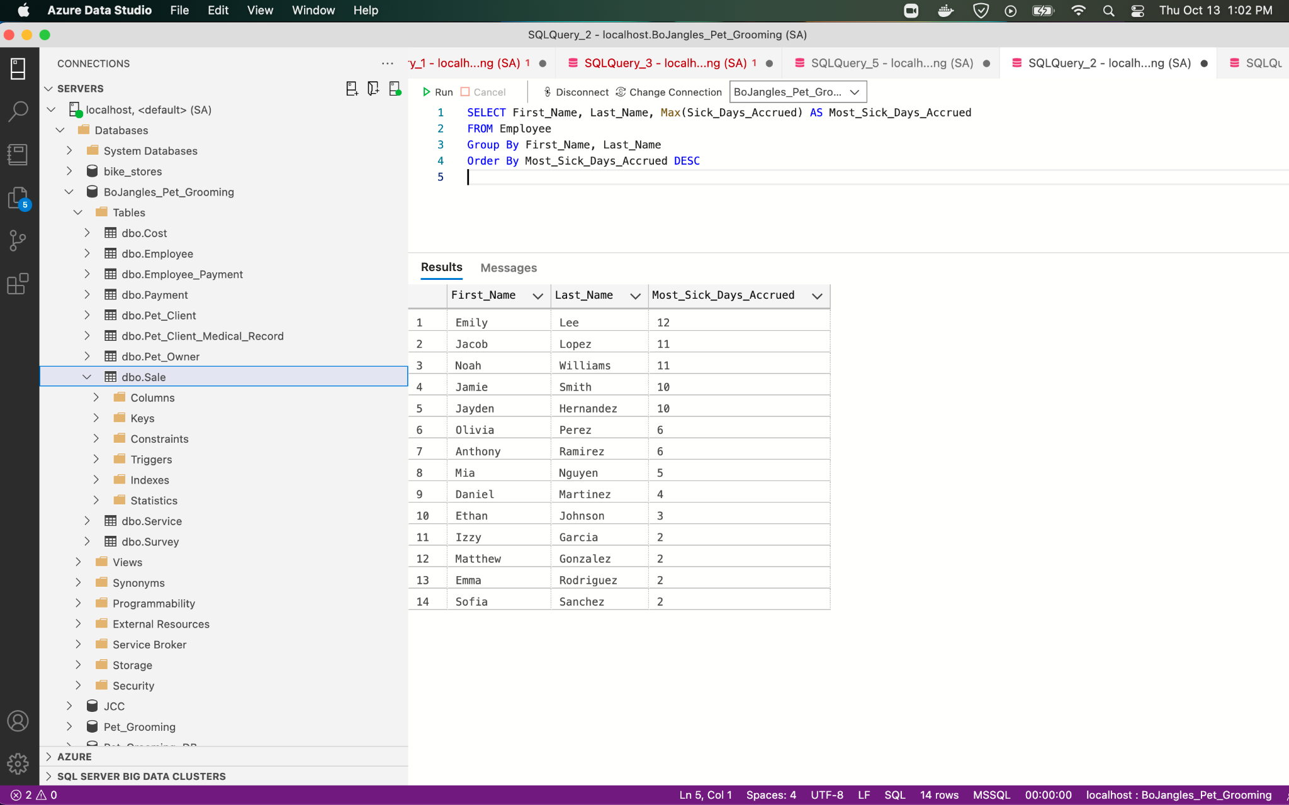

# 

# Technical issues, quirks of the system, major challenges

Our team faced many challenges and technical issues throughout this project. Our first struggle was when designing our ERD. It was a challenge trying to find the relationships between each table and entity. We also struggled with understanding the use of reference tables to build our ERD. These two were crucial for us to grasp because of how important they are in the database modeling and design phase. The third challenge was the limited data we had to work with.

# 

# Lessons learned

One of the main lessons our team learned was that creating an ERD and normalization requires a good time investment since it's the core of the entire project. Izzie and Jamie need some basic knowledge of how this is interpreted in the database system to understand what the database is generating and how the company is doing. Our team also learned that data entry for the tables is quite a task without prior scripting knowledge. With that said, It’s very easy to make a mistake when transferring data into the database. Our suggestion for Izzi and Jamie is to be meticulous when transferring paper based data into the database. The database system can generate quality content only if the data inputted is good, clean data.

# 

# Selling the Company (Scenario B)

Like most successful companies it is prudent for Mr. Bo Jangles Salon to consider an exit strategy. One of these such avenues is outright selling to a larger firm. During this process the owners will want to present their company so that it fetches the highest valuation possible.

Our new database will help provide a few tools that would be useful to the salon to help itself along this process.

1. The first focus would be on things that have real value. A question any acquiring company will ask is: “What are we getting for our money?” We have included a table listing all of the tangible assets the company possesses. This establishes a nice base of what the acquirer can see they are getting. The table can be easily updated through the database management system every time a new asset is added. If the client does not feel comfortable doing this task themselves, it could also become a sustainment activity that would be ongoing revenue for our consulting group.



1. The next tool we have for our client are reports showing prior quarters revenue. These reports have queried the revenue generated by the company between dates selected at the beginning and end of each quarter. Part of the acquisition process is to look at how revenue is trending over time. Before we developed this for the client, they would just have to ask a larger company to trust them, or look at their bank statements and try to decipher what is going on. Now it is all in one place so that a decision can be easily made.

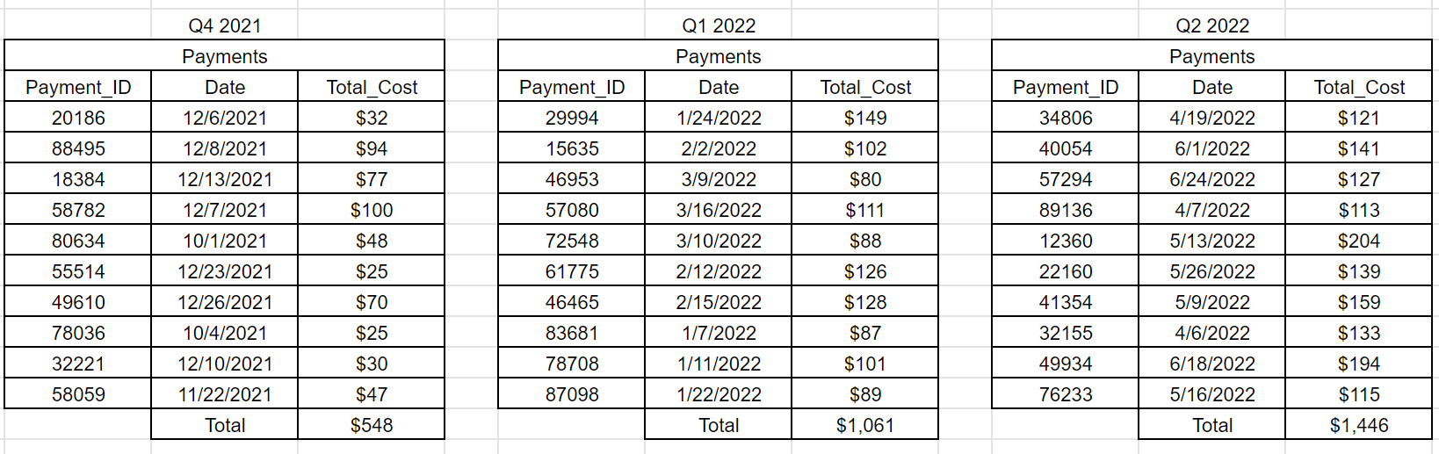

1. The third element of our approach would be framing the results of customer satisfaction scores. Once current revenue is established, an acquirer will want to know: “How much can the company grow from here?” Customer ratings can be a great indicator for how well the business is perceived in the market. Who better to provide honest analysis than the paying customers themselves? As surveys are completed by customers, the results can now be stored and aggregated in our new database. From there queries can show the details of the scores. Any potential company that might be looking to buy the salon can see how well the salon is doing and be confident that more customers will continue to come and that revenue will continue to grow in the future.

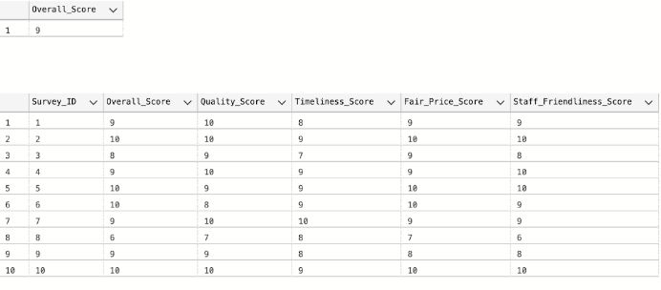

# 

# Appendices (labeled):

A) All SQL scripts (SOURCE CODE), i.e., queries/results, triggers, view,

procedures, database

B) Screenshots of your handout/presentation (4 slides per page maximum). The client will look at these if unable to run your presentation

1. SQL Scripts:

INSERT INTO Survey

(Survey_ID, Overall_Score, Quality_Score, Timeliness_Score, Fair_Price_Score, Staff_Friendliness_Score)

VALUES

(1, 9, 10, 8, 9, 9),

(2, 10, 10, 9, 10, 10 ),

(3, 8, 9, 7, 9, 8 ),

(4, 9, 10, 9, 9, 10 ),

(5, 10, 9, 9, 10, 10 ),

(6, 10, 8, 9, 10, 9 ),

(7, 9, 10, 10, 9, 9 ),

(8, 6, 7, 8, 7, 6 ),

(9, 9, 9, 8, 8, 8 ),

(10, 10, 10, 9, 10, 10 )

;

INSERT INTO Payment

(Payment_ID, Method, Date, Total_Cost)

VALUES

(111, 'Cash', '08-03-2022' , $20.00),

(112, 'Debit', '08-05-2022', $25.00),

(113, 'Credit', '08-10-2022', $30.00),

(114, 'Debit', '08-15-2022', $45.00),

(115, 'Debit', '08-25-2022', $40.00),

(116, 'Cash', '08-29-2022', $55.00),

(117, 'Credit', '09-05-2022', $50.00),

(118, 'Credit', '09-15-2022', $65.00),

(119, 'Debit', '09-25-2022', $60.00),

(120, 'Cash', '10-10-2022', $70.00)

;

INSERT INTO Cost

(Service_Cost_ID, Service_Name, Cost_per_Unit, Service_Description)

VALUES

(001, 'Basic Service', $20.00, 'S - Bath, Blow Dry, and Brush'),

(002, 'Basic Service', $30.00, 'S - Bath, Blow Dry, and Brush'),

(003, 'Basic Service', $40.00, 'S - Bath, Blow Dry, and Brush'),

(004, 'Basic Service', $50.00, 'S - Bath, Blow Dry, and Brush'),

(005, 'Basic Service', $60.00, 'S - Bath, Blow Dry, and Brush'),

(006, 'Basic Service', $25.00, 'L - Bath, Blow Dry, and Brush'),

(007, 'Basic Service', $45.00, 'L - Bath, Blow Dry, and Brush'),

(008, 'Basic Service', $55.00, 'L - Bath, Blow Dry, and Brush'),

(009, 'Basic Service', $65.00, 'L - Bath, Blow Dry, and Brush'),

(010, 'Basic Service', $70.00, 'L - Bath, Blow Dry, and Brush'),

(011, 'Specialty Service ', $8.00, 'Nail Trim'),

(012, 'Specialty Service ', $5.00, 'Ear Cleaning'),

(013, 'Specialty Service ', $25.00, 'Skin Scrape'),

(014, 'Specialty Service ', $10.00, 'Ear Mite Treatment'),

(015, 'Specialty Service ', $15.00, 'Flea Treatment'),

(016, 'Specialty Service ', $12.50, 'Tick Treatment'),

(017, 'Specialty Service ', $8.50, 'Teeth Brushing'),

(018, 'Specialty Service ', $6.00, 'Nose & Pad Conditioning'),

(019, 'Specialty Service ', $7.50, 'Eye Cleaning & Drops'),

(020, 'Specialty Service ', $15.00, 'Hair Cut'),

(021, 'Specialty Service ', $4.00, 'Chalking (5 colors available)'),

(022, 'Specialty Service ', $7.00, 'Stenciling (20 designs, 8 colors)'),

(023, 'Specialty Service ', $5.00, 'Feathering (6 options'),

(024, 'Specialty Service ', $15.00, 'Vitamins (soft shiny coat'),

(025, 'Specialty Service ', $30.00, 'Matted Hair')

;

INSERT INTO Pet_Client

(Pet_Client_ID, Pet_Owner_ID, Pet_Name, Species, Breed, Primary_Color, Secondary_Color, Weight, Hair_Length, Age, Birthdate, Gender, Date_Last_Seen, Number_of_Visits, Number_of_Services_Performed)

VALUES

(1, 101, 'Bella', 'Cat', 'Siamese Cat', 'Brown', 'White', 20 ,'L', 8, '2/10/2014', 'F', '9/22/2022', 2, 5)

(2, 102, 'Luna', 'dog', 'pug', 'White', 'N/A',0, 'S', 3, '3-11-2019', 'F', '04-27-2022', 4, 4),

(3, 103, 'Lucy', 'dog', 'pug', 'White', 'N/A', 40, 'S', 6, '3-11-2016' , 'F' , '01-28-2022', 1, 3),

(4, 104, 'Daisy', 'cat', 'siamese cat', 'Brown', 'Gray', 55, 'L', 6, '2-10-2016', 'M', '05-24-2021', 1, 2),

(5, 105, 'Lola', 'dog', 'pug', 'White', 'Black', 60, 'S', 9, '2-10-2013', 'F', '06-09-2021', 5, 7),

(6, 106, 'Sadie', 'cat', 'siamese cat', 'Black', 'N/A', 15, 'S', 11, '4-9-2011', 'F', '08-27-2021', 3, 4),

(7, 107, 'Molly', 'dog', 'pug', 'White', 'N/A', 30, 'L', 4, '4-10-2018', 'M', '09-2-2021' , 5, 7),

(8, 108, 'Bailey', 'dog', 'pug', 'Brown', 'N/A', 25, 'L', 2, '2-10-2020', 'F', '05-21-2021', 7, 7),

(9, 109, 'Stella', 'dog', 'pug', 'Brown', 'N/A', 70, 'S', 3, '2-11-2019', 'M', '06-08-2022' , 1, 2),

(10, 110,'Maggie', 'dog', 'pug', 'Black', 'Brown', '82', 'S', 5, '6-10-2017', 'M', '05-04-2022', 3, 3)

;

INSERT INTO Employee

(Employee_ID, SSN, First_Name, Last_Name, Start_Date, Address, Degree_Name, Grad_Date, Years_of_Experience, School_Name, Certificate_Date, Sick_Days_Accrued, Vacation_Days_Accrued, Paycheck_ID)

VALUES

(50935, 284274009, 'Izzy', 'Garcia', '01-01-2020', '156 Broadway', null, null, 2, null, null, 2, 18, 36213),

(10506, 423174174, 'Jamie', 'Smith', '01-01-2020', '897 43rd St', null, null, 2, null, null, 10, 17, 61085),

(44274, 247172055, 'Jacob', 'Lopez', '05-06-2020', '155 Hobart', 'Business', '06-15-2018', 1, 'Sonoma', null, 11, 14, 46883),

(47281, 875389498, 'Jayden', 'Hernandez', '06-07-2020', '574 Grendal', 'Business', '05-12-2017', 2, 'Irvine', null, 10, 12, 30925),

(88087, 638231155, 'Daniel', 'Martinez', '07-06-2021', '875 Rose', null, null, 1, 'Riverside', '06-13-2016', 4, 14, 23358),

(39862, 620757521, 'Emma', 'Rodriguez', '10-06-2021', '315 Willow', null, null, 2, 'Davis', '05-14-2018', 2, 5, 69914),

(77855, 598498666, 'Ethan', 'Johnson', '09-01-2020', '301 Grove', null, null, 1, 'Sacramento', '06-15-2016', 3, 20, 47802),(62618, 131456195, 'Emily', 'Lee', '12-06-2021', '385 Thacher', null, null, 2, 'Chico', '05-14-2018', 12, 15, 73426),

(51855, 581545591, 'Matthew', 'Gonzalez', '04-07-2020', '511 Harrison', null, null, 1, 'Merced', '05-14-2018', 2, 12, 81919),

(26042, 371143587, 'Mia', 'Nguyen', '03-25-2021','102 Ocean', null, null, 2, 'Hayward', '05-15-2016', 5, 21, 23873),

(26679, 656809632, 'Noah', 'Williams', '06-30-2020', '258 Lincoln', null, null, 1, 'Berkeley', '06-15-2017', 11, 27, null),

(67525, 583737103, 'Olivia', 'Perez', '09-20-2020', '294 Miller', null, null, 2, 'San Marcos', '05-14-2018', 6, 10, null),

(87637, 873429702, 'Anthony', 'Ramirez', '01-22-2020', '134 First', null, null, 1, 'San Diego', '05-15-2016', 6, 30, null),

(12348, 167236943, 'Sofia', 'Sanchez', '08-08-2021', '416 Lima', null, null, 2, 'Santa Barbara', '06-15-2017', 2, 7, null)

;

INSERT INTO Pet_Client_Medical_Record

(Medical_Record_ID, Pet_Client_ID, Rabies_Vacc_Status, Spayed_or_Neutured)

VALUES

(101, 1, 'Y', 'S')

(102,2,'Y','S'),

(103,3,'Y','S'),

(104,4,'N','N'),

(105,5,'Y','S'),

(106,6,'N','S'),

(107,7,'N','S'),

(108,8,'Y','S'),

(109,10,'Y','N'),

(110,10,'Y','N')

;

INSERT INTO Pet_Owner

(Pet_Owner_ID, First_Name, Middle_Initial, Last_Name, Email, Phone, Date_Last_Seen, Number_of_Visits, Pet_Client_ID)

Values

(101, 'Alisha', 'H', 'Welton', 'awelton@outlook.com', '(816) 597-3654','09-07-2021', 2, 1,),

(102, 'Hamza', '', 'Walsh', 'hwalsh@outlook.com','(625) 555-0511', '04-27-2021', 4, 2),

(103, 'Danika','B','Soto','dsoto@yahoo.ca', '(380) 295-6543', '01-28-2022', 1, 3),

(104, 'Callie','','Colon','ccolon@gmail.com','(767) 484-3604','05-24-2021', 1, 4),

(105, 'Hamza','','Mercado','hmercado@aol.ca','(902) 286-9970','06-09-2021', 5 ,5),

(106, 'Finnegan','','Jackson','fjackson@gmail.com','(302) 580-1523','08-27-2021',3,6),

(107, 'Humberto','','Phillips','hphilips@gmail.ca','(233) 240-1165','09-02-2021', 5, 7),

(108, 'Damian','','Ballard','dballard@aol.ca','(767) 484-3603','05-21-2021', 7, 8),

(109, 'Oliver','P','Rangel', 'orangel@ccglobal.ca','(626) 588-8314','06-08-2022',1,9),

(110, 'Dorian','','Berg',' dberg@yahoo.ca','(767) 484-3605','05-06-2022', 3, 10)

;

INSERT INTO Employee_Payment

(Paycheck_ID, Statement_ID, Pay_Period_Start_Date, Pay_Period_End_Date, Date_Issued, Employee_Type, Bank_Name, Account_ID,

Direct_Deposit, Hourly_Rate, Hours_Worked, Statement_Total_Amount, Medical_Deduction, Dental_Deduction, Disability_Deduction, Life_Insurance_Deduction, Statement_Net_Amount)

VALUES

(36213, 40959, '06-10-2022', '06-24-2022', '07-01-2022', 'O', 'Chase', 48031, 'Y', 35, 21 , $735, 40, 10, 15, 15, $655),

(61085, 12342, '06-10-2022', '06-24-2022', '07-01-2022', 'O', 'Citi', 42479, 'Y', 35, 23, $805, 40, 10, 15, 15, $725),

(46883, 62606, '06-10-2022', '06-24-2022', '07-01-2022', 'F', 'Chase', 85834, 'Y', 23, 31, $713, 40, 10, 15, 15, $633),

(30925, 45881, '06-10-2022', '06-24-2022', '07-01-2022', 'F', 'Citi', 79536, 'Y', 23, 32, $736, 40, 10, 15, 15, $656),

(23358, 64731, '06-10-2022', '06-24-2022', '07-01-2022', 'F', 'Chase', 76122, 'Y', 18, 25, $450, 40, 10, 15, 15, $370),

(69914, 29699, '06-10-2022', '06-24-2022', '07-01-2022', 'F', 'Citi', 82926, 'Y', 26, 21, $546, 40, 10, 15, 15, $466),

(47802, 46722, '06-10-2022', '06-24-2022', '07-01-2022', 'F', 'Chase', 46195, 'Y', 27, 21, $567, 40, 10, 15, 15, $487),

(73426, 23852, '06-10-2022', '06-24-2022', '07-01-2022', 'F', 'Chase', 46195, 'Y', 28, 22, $616, 40, 10, 15, 15, $536),

(81919, 46740, '06-10-2022', '06-24-2022', '07-01-2022', 'F', 'Chase', 18594, 'Y', 29, 35, $735, 40, 10, 15, 15, $655),

(23873, 64549, '06-10-2022', '06-24-2022', '07-01-2022', 'F', 'Citi', 22082, 'Y', 27, 22, $594, 40, 10, 15, 15, $514)

(58800, 80123, '06-10-2022', '06-24-2022', '07-01-2022', 'F', 'Chase', 12104, 'Y', 21, 25, $441, 40, 10, 15, 15, $361,),

(71837, 76521, '06-10-2022', '06-24-2022', '07-01-2022', 'F', 'Chase', 67819, 'Y', 26, 22, $445, 40, 10, 15, 15, $365,),

(33196, 43866, '06-10-2022', '06-24-2022', '07-01-2022', 'P', 'Citi', 42637, 'Y', 27, 10, $270, 0, 0, 0, 0, $270,),

(35933, 70430, '06-10-2022', '06-24-2022', '07-01-2022', 'P', 'Chase', 39378, 'Y', 27, 12, $324, 0, 0, 0, 0, $324,),

;

INSERT INTO [Service]

(Service_ID, Sale_ID, Service_Cost_ID, Quantity)

VALUES

(4001,001,2),

(4002,002,4),

(4003,003,1),

(4004,004,3),

(4005,005,1),

(4006,006,2),

(4007,007,1),

(4008,008,3),

(4009,009,1),

(4010,010,2)

;

INSERT INTO Sale

INSERT INTO Sale

(Sale_ID, Pet_Client_ID, Service_ID, Payment_ID, Employee_ID, Survey_ID)

VALUES

(201, 1, 4001, 111, 50935, 1),

(202, 2, 4002, 112, 10506, 2),

(203, 3, 4003, 113, 44274, 3),

(204, 4, 4004, 114, 47281, 4),

(205, 5, 4005, 115, 88087, 5),

(206, 6, 4006, 116, 39862, 6),

(207, 7, 4007, 117, 77855, 7),

(208, 8, 4008, 118, 62618, 8),

(209, 9, 4009, 119, 51855, 9),

(210, 10, 4010, 120, 26042, 10)

;

**B)Screenshots of Presentation** 